 
Abstract — Development of the computer based system for strabismus and amblyopia therapy is discussed in the paper. In the case of amblyopia or 'lazy-eye' syndrome, the therapy is typically conducted in two ways: by wearing a patch over the non-amblyopic eye for several hours per day or blurring the vision in the good eye with penalizing drops or with extra power in the glasses. The disadvantage of this types of therapy is the lack of binocular vision. The proposed approach retains binocular vision. Parameters corresponded to strabismus can be measured much faster using the described system. Another advantage is that therapy may take place at user's home, without time-consuming visits to the clinic.
Computer based system for strabismus and amblyopia therapy

Introduction
Adistance between human eyes is about 65mm, thus the objects seen by each retina is slightly different. This type of vision is important in depth perception and it is called a stereoscopic vision. If human has a squint, the two eyes focus on different spots. In persons with a squint this does not usually cause 'double vision'. In children the brain quickly learns to ignore the signals coming from the turned eye. The child then only sees with one eye. It is important to diagnose a strabismus and amblyopia as early as possible [1][2]. The proposed system allows one to quickly measure and to treat the strabismus and amblyopia in children and in youth.

System Description
The system is based on the assumption that to each eye different images are provided. The image for non-dominant eye is geometrically transformed. The transformation parameters are selected in the measuring process and are proportional to the sum of the image transformations in the glasses lens and the examined eye dysfunctions. As a result of synthesis of transformed images in the brain the "baseline" between the eyes is produced, and rendered a single integrated image.
The design of the system allows to conduct measurements and therapy involving both therapist and without the participation of a specialist. The application consists of four main elements (see Fig. 1): calibration module; measurement management module; therapy managements module; data access module.

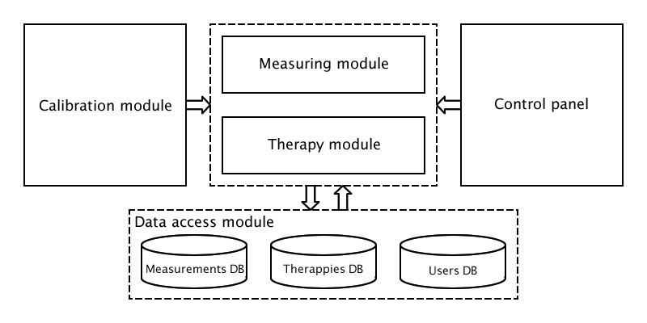
Fig. 1 Software system architecture

Adobe Flex and Visual C++ 2005 as the development platforms and ActionScript 3 and C++ as programming languages to develop the system software was used.

Calibration management module
Calibration management module is a functional element of the system which allows to customize colors depth and brightness of the images presented on the LCD display. Parameters of the displayed images are selected in order to effectively increase behavior of color filters used in glasses. The calibration is intended to minimize the formation of the so-called shadows in the images. Undesirable effects, which are the result of imperfect filtering of the anaglyph glasses, are minimized by the calibration process. A preliminary calibration is realized by means of a hardware calibrator. Then calibration for a specific model of glasses is performed in following way: user applies glasses to the monitor in such a way that the color filters in the glasses match to the image of the glasses displayed on the computer monitor. In order to properly choose the image color components dedicated for each eye the user sets the parameters (for example Left Eye section on Fig. 2) so that the resulting color image seen through the filter in the glasses is uniform.

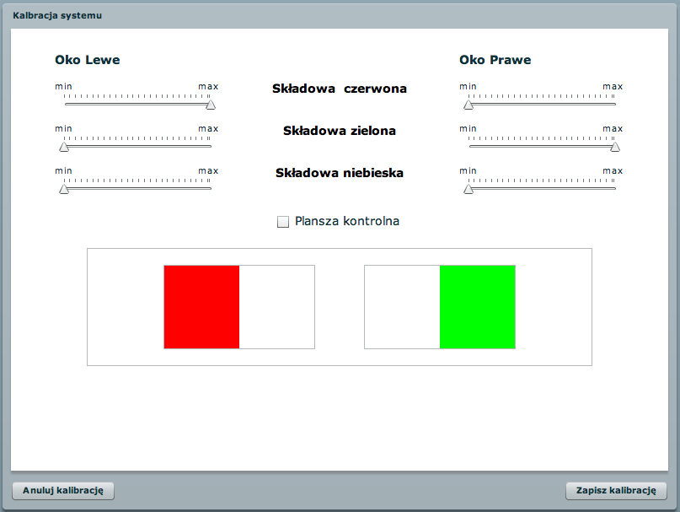
Fig. 2 Calibration panel

The adjustment is repeated for each separate color filter in the glasses. User also has a control image to verify the correctness of the realization of the calibration process.

Measurement management module
Measurement management module is responsible for survey data acquisition and processing. Data are obtained in center points (so-called control points) of 9 areas of equal size on which patient directs his eyes holding his head still. Due to this division of the screen the same range of parameters values for each measuring point are guaranteed.

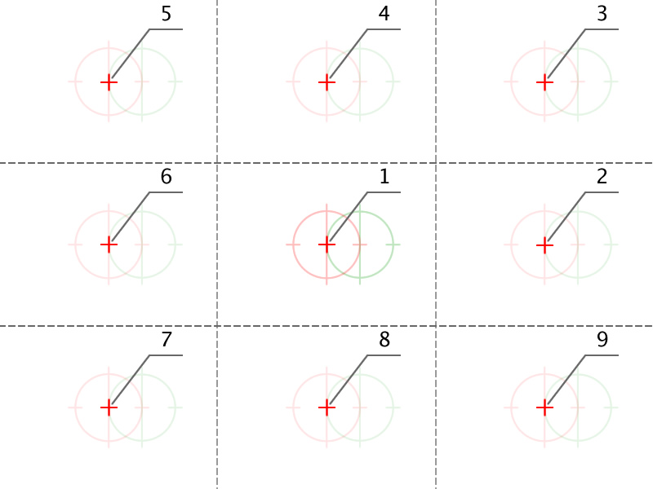
Fig. 3 Measurement points grid

The computer screen was divided in such a way that the angle of seeing and range of measured parameters are maximized.
In the case of squint or amblyopia one of the eye is the dominant eye. For this reason the system requires measurements in the points of the screen in two configurations: dominant eye left, dominant eye right [3]. Measurements are managed via the control panel. Therapist is able to control the following parameters:
- dominant eye (left or right),
- measurement point (1 of 9 from the measurement grid).
Starting position (red and green sign, left and right eye respectively) of each measuring point is presented at Fig. 4. Fig. 4 shows the starting position with the assumption that the measurement is performed for the right eye and the left eye is the dominant eye.

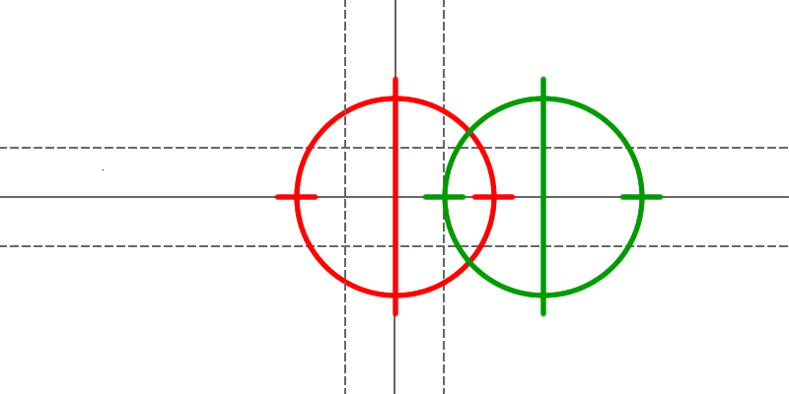
Fig. 4 Initial position

The examined person has to modify available transformation parameters of sign (vertical and horizontal position, scale rotation) to finally see one sign (two overlapping signs). The person who wears glasses should be wearing them during the test. Modification of the height of the sign image (see Fig. 5) allows to eliminate the impact of anisometropia (the condition in which the two eyes have unequal refractive power) [2][4].

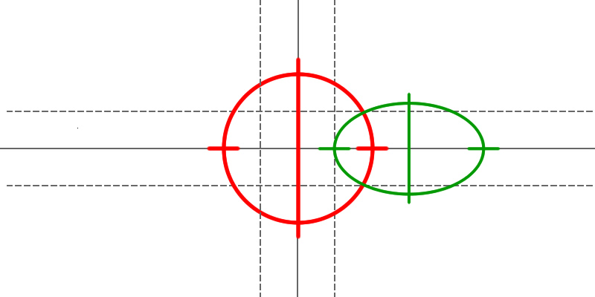
Fig. 5 Vertical scale transformation

The new width and height of the image (that is, enlarging or shrinking) was calculated by using the matrix form (1).
$\left[\begin{matrix}x' \\ y'\end{matrix}\right]=\left[\begin{matrix}s_{x} & 0 \\ 0 & s_{y}\end{matrix}\right]\left[\begin{matrix}x \\ y\end{matrix}\right]$ (1)

Modification of the width of the sign image (see Fig. 6) allows to eliminate the impact of regular astigmatism, that is relevant to determine the proportion of width to height.

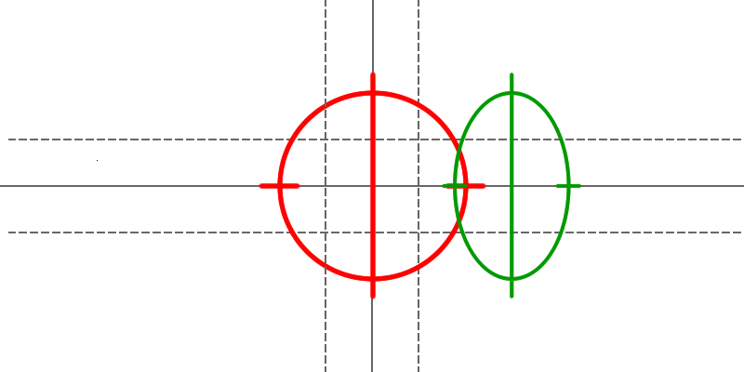
Fig. 6 Horizontal scale transformation

Modification of the vertical position parameter (see Fig. 7) allows to compensate hypertropia (eye that turns upwards) or hypotropia (eye that turns downwards) image destortion results.

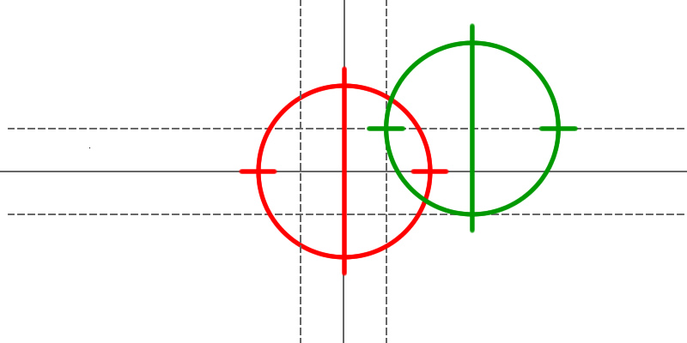
Fig. 7 Vertical position transformation

The vertical translation of the image was calculated by using (2). The t_{y} specify the desired vertical pixel displacement.

$\begin{aligned}y'=y+t_{y} \\ x'=x\end{aligned}$ (2)

Modification of the horizontal position parameter (see Fig. 8) allows to compensate the squint angle. In addition, this parameter depends on the distance of eyes from the computer monitor.

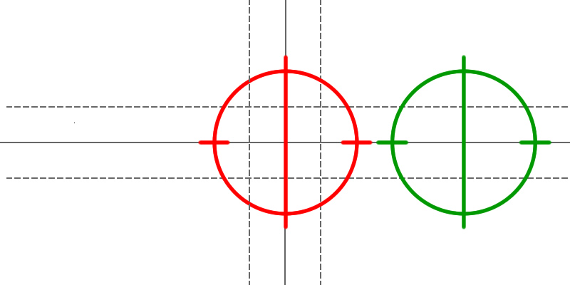
Fig. 8 Horizontal position transformation

The horizontal translation of the image was calculated by using (3). The t_{x} specify the desired horizontal pixel displacement.

$\begin{aligned}x'=x+t_{x} \\ y'=y\end{aligned}$ (3)

Modification of the rotation parameters between -45 and +45 degrees (see Fig. 9) allows compensating oblique squint (strabismus obliquus) image distortion results.

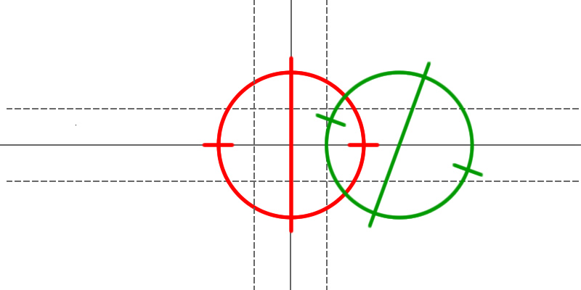
Fig. 9 Rotation by the 20 degrees clock wise the origin

The rotation of the image by an angle clockwise about the origin was calculated by using (4).

$\left[\begin{matrix}x' \\ y'\end{matrix}\right]=\left[\begin{matrix}\text{cos}(q) & \text{sin}(q) \\ −\text{sin}(q) & \text{cos}(q)\end{matrix}\right]\left[\begin{matrix}x \\ y\end{matrix}\right]$ (4)

Similarly, the rotation of the image by an angle counterclockwise about the origin was calculated by using (5).

$\left[\begin{matrix}x' \\ y'\end{matrix}\right]=\left[\begin{matrix}\text{cos}(q) & −\text{sin}(q) \\ \text{sin}(q) & \text{cos}(q)\end{matrix}\right]\left[\begin{matrix}x \\ y\end{matrix}\right]$ (5)

The described parameters can be controlled by mouse and keyboard shortcuts. The result of the examination is a set of 18 vectors that includes measurement parameters, corresponding to eyes disease in each point. Obtained in this way set of parameters is used as input to the visual therapy module.

Therapy management module
Therapies are managed via the control panel. Therapist is able to control the following parameters:
- dominant eye (left or right),
- exercise (next, previous - in accordance with a list of exercises),
- transparency animation,
- measurement point (1 of 9 from the measurement grid),
- automatic measurement points change,
- type of therapy (step by step/smooth).
Transparency animation is a transformation of a image dedicated to non-amblyopic eye. Image is modulated in such a way as to stimulate the amblyopic eye without penalizing the non-amblyopic eye. The system allows the user to perform training, using a set of vectors obtained from the examination. Images displayed on the monitor are modified according to those results. During the training user has to lead eyes on sign displayed on the screen. The sign position is changing in accordance to order and placement of measurement points. Two training algorithms have been developed:
- step algorithm – after a certain period of time the image of the sign jumps to the next point,
- smooth algorithm. - the sign goes smoothly to the next point.

Data access module.
Data access module provides mechanisms for the storage and access to data. Database stores information about users (patients) and all information about the examinations and therapies, which allows to track progress of the therapy.

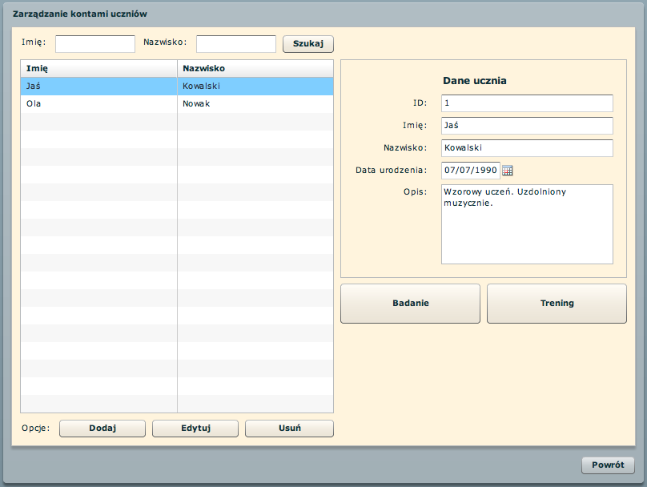
Fig. 10 Data access GUI

This part of the system supplies also mechanisms for authentication and authorization process. Fig. 10 shows the graphical user interface of the users management screen.

Conclusion
The developed system allows one to examine and to treat squint (small and middle range) and amblyopia. One of the biggest advantages of it is that it can be used with a typical personal computer, equipped with an LCD display (minimal required resolution is 1280x1024 pixels). An end user should be additionally equipped only with anaglyph glasses. Compared to traditional methods of treatment, the proposed approach is characterized by much more wide possibilities. The user can perform exercises without leaving their home. Owing to that this kind of exercises can be performed much more frequently, bringing a positive effect on the outcome of the treatment. The examined person has an incomitant squint. In that case when he/she looks to the right, the eyes are aligned. When he/she looks to the left, one eye may not move as far and the eyes are then not aligned. In these cases the application measures the eye muscle tension as a function of distance from the center of the screen.

References
- Hao-jun Li, Fei-yue Qiu, Li-ping Wang , “Research on the Amblyopia Objectivity Examination System Based on Eye Electrophysiology Technology”, Int. Conf. Bioinformatics and Biomedical Engineering, July 6-8, 2007, pp. 1072 - 1075 .
- S. P. Donahue, “Relationship Between Anisometropia, Patient Age, and the Development of Amblyopia”, AJA vol. 142, July 2006, pp. 132-140. H. Poor, An Introduction to Signal Detection and Estimation. New York: Springer-Verlag, 1985, ch. 4.
- S. A. Larson, R. V. Keech, R. E. Verdick, “The threshold for the detection of strabismus”, Journal of American Association for Pediatric Ophthalmology and Strabismus vol. 7, Dec. 2003, pp. 418-422.
- A. Leon, S. P. Donahue, D. G. Morrison, R. L. Estes, C. Li, “The relationship between magnitude of anisometropia and amblyopia depth”, Journal of AAPOS vol. 11, Feb. 2007, pp. 80.
- E. C. Campos, “Future directions in the treatment of amblyopia”, The Lancet Volume: 349, Issue: 9060, Apr. 26, 1997, pp. 1190

  Research funded within the project No. POIG.01.03.01-22-017/08, entitled "Elaboration of a series of multimodal interfaces and their implementation to educational, medical, security and industrial applications". The project is subsidized by the European regional development fund of the and by the Polish State budget".

